



**INTEGRATED LIBRARY MANAGEMENT SYSTEM**

**TECHNICAL PROPOSAL**

**PREPARED BY:** **Infonans Solution PLC**

**PREPARED FOR:** **Debark University**

**VERSION:** **1.0**

**DATE:** **January 2020**

Contents

6.8 Integrated library management system 3

6.8.1. Proposed ILMS solution 4

6.8.2 System Work Flow 7

6.8.3 Conversion station 8

6.8.5.3 RFID tag 10

Key Benefits: 11

6.8.4 UHF shelf management system 12

Key Benefits 13

6.8.5 ILMS system software 14

6.8.6 SQL Server Management Studio 2017 15

## Integrated library management system

An Integrated Library Management System is a computer-based system used to manage internal and external resources including tangible assets, financial resources, materials, and human resources. It performs library automation and collection development tasks broken down into different modules that are focused on simplifying tasks such as acquisition, cataloguing, and circulation commonly done in any library. It is built on a centralized database and normally utilizes a common computing platform and consolidates all library operations into a uniform and enterprise wide system.

The RFID technology is very new concept for Ethiopian university. A library is a growing organism. As it grows in size the problems associated with the maintenance and security of the documents also grows. The proposed RFID-based library management system is implemented with a passive tag attached to the book. The tag stores electronic information about the book such as ISBN number, book title, name of the author, and publisher. The proposed system is easier in inventorying, book tracking, material handling, and other essential library transactions. Basic tasks in library management include the planning of acquisitions of materials, arranging the acquired materials according to the library classification, preservation of materials and developing and administering library computer systems. Here we mentioned Management problems being faced by Library: -

* Increasing theft
* Misplacement of reading material
* Poor Inventory Accuracy
* Poor Stock verification process
* Require of Security control
* Traditional methods of stock verification are not feasible for libraries having large collections.
* Searches Take Longer time

### Proposed ILMS solution



The proposed ILMS system plays a very important role in redefining the library process to make everyone’s job easier right from the users to library staff. It provides a platform to automate most of the process performed by the library staff like check in-check out, sorting, stock management and inventory control. RFID is an innovative automated library system for automatic identification and tracking of library material. As it is combination of radio-frequency-based technology and microchip technology and can be used to identify, track, sort or detect library holdings. This is an effective way of managing collections of the library and providing enhanced services to the users.

#### Benefits of the proposed integrated library management system:

* Does not need the manual typing so ensuring accuracy in routine works
* Hassle free issue/return of books since several books in a pile can be issued/ returned at a time.
* Helpful in identifying misfiled items.
* Inventory visibility, accuracy and efficiency.
* Automated Issue/Return
* No lines or greatly reduced lines at the check-out counter.
* Increases the security function in library.
* Instant update of the databases is possible.
* Improved utilization of resources like manpower, infrastructure etc.
* Less time consumption as line of sight and manual interaction are not needed for RFID-tag reading.
* Unique ID of RFID tag prevents counterfeiting.
* Open access system promotes chances of theft of books, so to secure the valuable resources form anti-social elements.
* Automation of repetitive work such as lending or returning of items

#### Advantage of ILMS system in Libraries

Librarians will find ILMS very useful as the technology provides a lot of advantages in the daily library management. The following are some of the major advantages this technology offers to the Libraries.

* **Rapid charging/discharging: -**The use of RFID reduces the amount of time required to perform circulation operations. The most significant time savings are attributable to the facts that information can be read from RFID tags much faster than from barcodes and that several items in a stack can be read at the same time. While initially unreliable, the anti-collision algorithm that allows an entire stack to be charged or discharged now appears to be working well.
* **High reliability: -**The readers are highly reliable. RFID library systems claim an almost 100 percent detection rate using RFID tags.
* **High-speed inventorying**: -A unique advantage of RFID systems is their ability to scan books on the shelves without tipping them out or removing them. A hand-held inventory reader can be moved rapidly across a shelf of books to read all of the unique identification information. Using wireless technology, it is possible not only to update the inventory, but also to identify items which are out of proper order.
* **Long tag life**: -RFID tags last longer than barcodes because nothing comes into contact with them. Most RFID vendors claim a minimum of 100,000 transactions before a tag may need to be replaced.
* **Fast circulation services**: -Application of RFID technology in libraries reduces the amount of time required to perform circulation operations
* **Easy self-charging/discharging:** For library members using self-charging, there is a marked improvement because they do not have to carefully place materials within a designated template and they can charge several items at the same time.
* **Fast inventorying: -**Another unique advantage of RFID system is their ability to scan books on the shelves without tipping them out or removing them. Since it is using wireless technology, it is possible not only to update the inventory, but also to identify items which are out of proper order.
* **Greater reliability: -**The RFID readers are highly reliable and RFID library systems claim an almost 100 percent detection rate using RFID tags.
* **Long tag life than Barcodes: -**It is important to note that RFID tags last longer than barcodes because nothing comes into contact with them. According to RFID vendors, the lifetime of a tag is about a minimum of 100,000 transactions which is better than barcodes.
* **Automated materials handling: -**Automated materials handling is another advantage of RFID technology which includes conveyer and sorting systems that can move library materials and sort them by category into separate bins or onto separate carts. This significantly reduces the amount of staff time required to ready materials for re-shelving in libraries.
* **Economy:** -Earlier implementation of RFID in libraries was costly but now it becomes economy while considering the advantages it offers to the library management.

### System Work Flow

Combined with techniques such as a database management system the RFID can provide automatic safe and coinvent instant surveillance functions. the system we proposed have Four main features.

* Library Security System.
* Conversion station
* Staff station
* UHF shelf management system

#### Library security system

When entering a facility, often the first point of entry is through a door. A common solution to secure the facility is to add a card or biometric reader and electric locks to the door. While a reader and lock require a valid credential to unlock the door. in the system proposed we used single and double barrier turnstiles in library gate and an Anti-Theft Gate which used to detect RFID tag that is equipped with EAS (Electronic Article Surveillance) capable of detecting the RFID tags within 1-meter range without interference of magnetic items, Which trigger the alarm system when an un-borrowed item passed through them. The alarm will sound and lights on the gate will flash as patron passes through with the un-borrowed library material. also, it has an option to trigger a Camera to record patrons who trigger the alarm to the Surveillance Station. Theft detection is an integral feature of the chip within the tag. It is a stand-alone technology, which operates independently of the library database.

KEY BENEFITS:

* Single technology is required for both inventory and theft management of the library.
* Library staff are alerted immediately when un-borrowed items pass through the theft detection gates.
* Would-be thieves are deterred by the physical presence of the gates.
* Number of patrons passing through the gates is captured by a counter on the gates Alarm volume can be easily controlled.
* Number of patrons passing through the gates is captured by a counter on the gates Alarm volume can be easily controlled.

**Hardware requirements**

##### UHF Detection Gates

The LibBest RFID EAS Gates we are going to use in this project is the anti-theft part of the Library RFID Management System using the same RFID tags embedded in the library items. Each lane is able to track items of about 1 meter and would trigger the alarm system when an un-borrowed item passed through them. The alarm will sound and lights on the gate will flash as patron passes through with the un-borrowed library material.

Features:

* Detect EAS Armed RFID tags
* Multi-item detection
* Able to integrate camera with the gate (Option)
* Gale to integrate with Surveillance Station (Option)

Key Benefits:

* Single technology is required for both inventory and theft management of the library.
* Library staff are alerted immediately when un-borrowed items pass through the theft detection gates.
* Would-be thieves are deterred by the physical presence of the gates.
* Number of patrons passing through the gates is captured by a counter on the gates Alarm volume can be easily controlled.

### Conversion station

Here we have conversion station where the library data is written to the tag. Conversion Station is a staff assisted station on services such as tagging and security operation. This conversion station is used to program RFID tags on new or existing library items. There are a variety of issues that need to be considered when choosing a tag, such as the optimal read range, the data you want to store on the tag, whether you are placing the tag in the spine of a book or the inside cover, and so forth. Each book would be uniquely identified via the RFID tags attached to it and communication would be done wirelessly. An RFID sensor would be placed near the library desk wherein one should only place the book near the sensor and it would get reissued/issued/returned depending on the actions required. Moreover, information regarding the asset i.e. book can be gained by both the authority and students remotely instead of the traditional way of manually searching the book. This would save a lot of time and enable efficient queue management. This station is used for the following services:

* Convert item barcode number and write into RFID tag memory
* Automatically dispenser RFID labels
* Fast processing means lower operation cost
* Equipped with touch screen, optical barcode scanner and RFID reader
* Enable to program or reprogram the RFID tags memory
* It is standalone operation, no need to connect with Integrated Library System
* Self-contained on portable cart in order to move between the stacks

The conversion station consists of the following components:

* Laptop PC with Windows 7 / 8 / 10
* 13-inch touch screen
* Keyboard and mouse
* RFID reader and Antenna
* Manual Label dispenser
* Handheld barcode scanner with stand
* Operation software

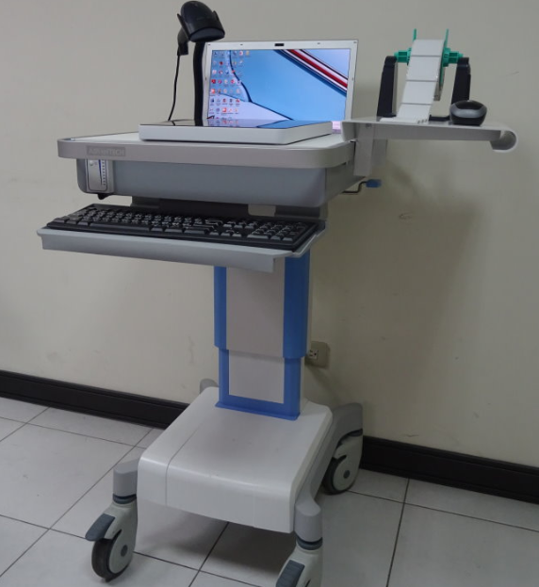

### RFID tag



RFID tags, or simply "tags", are small transponders that respond to queries from a reader by wirelessly transmitting a serial number or similar identifier. They are heavily used to track items in production environments and to label items. The size of the chip depends mostly on the Antenna. Its size and form are dependent on the frequency the tag is using. The size of a tag also depends on its area of use. It can range from less than a millimeter for implants to the size of a book in container logistic. The chip also has a "multi-read" function, which means that several tags can be read at once. It is thin, flexible and thus can be laminated between papers. With special method to attach to books, patron is totally unaware that the tag is there.

|  |  |
| --- | --- |
| Features | Description |
| Integrated Circuit (IC): | NXP U-Code G2iM |
| Standard | ISO 18000-6C |
| Memory | 256-bit EPC, 512-bit User Memory |
| rating frequency | 860-960 MHz (UHF) |

Key Benefits:

* No line of sight needed
* Allows to check-out and check-in several items simultaneously
* Information directly attached to product
* Performing both identification and anti-theft in one single operation
* Different shape and sizes available
* Able to tag almost anything
* Accelerate scanning and identifying

#### Staff station

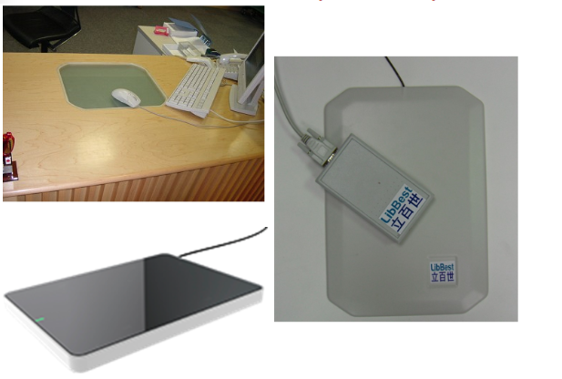

Staff Station is a staff assisted station on services such as loan, return, tagging, sorting and etc. It is loaded with arming/disarming module, tagging module and sorting module. Arming/Disarming module allows EAS (Electronic Article Surveillance) bit inside the tag of the library material to be set/reset so as to trigger/not trigger the alarm of the EAS gate. Checking of EAS status of library material is easy. The staff puts the item on the reader and click on the view to display the information stored inside the tag and status of EAS. There are also feature of Auto Arming and Auto Disarm. Auto Arm/Disarm will automatic arm/disarm library material that is within the Reader range. Together with circulation module from Library Management System Software, this station is used for the following services:

* Editing and updating of patron’s record
* Add and deleting of patron’s record
* Generate loan history for a particular patron
* Managing of fines incurred by the patron
* Arm/Disarm of EAS bit inside the library material
* Program of new library material
* Sort item in accordance to their branch and category number
* The features of this station depend on the module loaded by the Library Management Software.

### UHF shelf management system

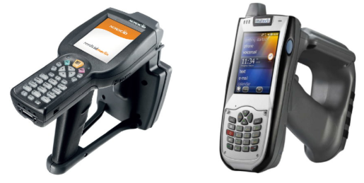

The Shelf Management Solution makes locating and identifying items on the shelves an easy task for librarians. It comprises basically of a portable scanner and a base station. this solution designed to cover three main requirements:

* Search for individual books requested
* Inventory check of the whole library stock
* Search for books which are miss-helved

All these functions are performed by sweeping the portable scanner across the spines of the books on the shelves to gather their identities. In an inventory check situation, the identities collected are compared with the database and a discrepancy report could be generated. In situations when search function is required, whether for a particular item or an item category, the information is first entered into the portable scanner from the base station, and when a foreign item is found on the shelves, a built-in beeper sound to alert the librarians.

Key Benefits

Changes inventory process:

* No more book handling: just pass the reader across shelved books to perform an instant inventory.
* Accuracy: book identification numbers are registered in the Shelf-Management Reader. The data is then downloaded to the central database.
* The fastest inventory you have ever made: 20 books per second.
* Notification: books to be pulled are up-loaded to the reader for quick identification.

User friendly:

* Light weight
* Wand allows easy reading of high and low shelves
* Saves time and resources:
* Implementers indicate a 75% reduction in human resources required for shelf management activities.

#### Desktop computer

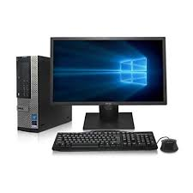

Intel Core i7 3.8GHz, 16GB DDR3, 1TB HDD, Windows 10 Pro 64-Bit, WiFi, USB 3.0, DVDRW, 2X Display Port

**Software requirements**

### ILMS system software

* Completely Web-based,
* run on browser. ̇Web-based Application –Asp.net, JavaScript, AJAX, XML, Web-Printing Supported ̇
* Multi-lingual Support –Full Unicode (UTF-8) Support ̇
* Standard Compliant –Marc21, UNI-Marc, ISO2709, Z39.50, MARCXML ̇
* Flexible –System modules can be tailored to meet the requirement of our library.
* ̇Customizable –Modifiable parameter enable libraries of any type to create unique management system of their own. ̇
* Reliable –Multi-tier Client/Server structure
* Multi-Libraries Support –Suitable for Large Scale Library and Multi-Libraries Library
* User-Friendly
* Quick Cataloging–Catalog with speed and efficiency
* Configurable–Flexible design of functions and reports
* Capable–Retrieve real-time library data faster
* Cataloging Functions
* New Functions
* Image of Book Cover
* Link to bookstore, internet resource

Book reviews

* Book Description, content table, price
* Shelf vs. Classification Number
* Periodical cover

Circulation

* Loan, return, renew, hold, trace, and recall items, overrides, internal circulation.
* Student Management-Comprehensive inquiry and maintenance functions
* Reports: Activity Summary, Inventory Report, Circulation Trace, Overdue Report, Outstanding Fines and Fees
* Check out count of book
* Circulation Follow up work
* Integrated with all hardware requirements to see the overall the systems in one place

### SQL Server Management Studio 2017

Microsoft SQL Server is a relation database management system developed by Microsoft. As a database server , it is a software product  with the primary function of storing and retrieving data as requested by other software application, which may run either on the same computer or on another computer across a network (including the Internet).

Features

* End-to-end database security with Always Encrypted
* Enhanced in-memory performance for all workloads
* Basic reporting
* Basic analytics
* Hybrid scenarios: Stretch Database, backup

|  |  |
| --- | --- |
| OLTP performance | |
| Maximum number of cores | 24 cores |
| Maximum memory utilized per instance | 128 GB |
| Maximum size | 524 PB |
| Basic high availability (2-node single database failover, non-readable secondary) | Support |
| Manageability (Management Studio, Policy-Based Management) | support |
| Basic Adaptive Query Processing (Interleaved execution) | Support |
| Basic security (Always Encrypted, Row-level security, data masking, basic auditing, separation of duties) | Support |
| T-SQL query across relational and Hadoop data with PolyBase | Support |

#### Windows Server 2019 Standard Edition operating system

System type software which is installed on the specified server machine for central database system. Windows Server 2019 is the latest version of the [server](https://en.wikipedia.org/wiki/Server_(computing)) [operating system](https://en.wikipedia.org/wiki/Operating_system) by [Microsoft](https://en.wikipedia.org/wiki/Microsoft), as part of the [Windows NT](https://en.wikipedia.org/wiki/Windows_NT) family of operating systems.

Windows Server 2019 has the following features

* Container services:
* Support for Kubernetes (stable; v1.14)
* Support for Tigera Calico for Windows

Storage:

* Storage Spaces Direct
* Storage Migration Service
* Storage Replica
* System Insights

Security:

* Shielded Virtual Machines
* Improved windows defender Advanced Threat Protection (ATP)

Administration:

* Window admin center
* Setup Diag

|  |  |  |  |  |
| --- | --- | --- | --- | --- |
| **DU-Integrated Digital Library System (ILSM) - BE** | | | | |
| **No.** | **Item Part Number** | **Item Description** | **Qty.** | **UoM** |
| **1** | **ILMS software** | |  |  |
|  | **ILMS system software** | • Completely Web-based,  • run on browser. ̇Web-based Application –Asp.net, JavaScript, AJAX, XML, Web-Printing Supported ̇ • Multi-lingual Support –Full Unicode (UTF-8) Support ̇ • Standard Compliant –Marc21, UNI-Marc, ISO2709, Z39.50, MARCXML ̇ | 1 | Pcs |
| **2** | **ILMS Gate detection** | |  |  |
|  | **RFID Detection Gates** | 1.capable of Detecting EAS Armed RFID tags 2.should Support AFI anti-theft figure 3.support Multi-item detection 4.support People Counter (In and Out) 5.shoud be Able to integrate camera with the gate if required  6.should be Able to integrate with Surveillance Station is required including base plat | 1 | Pcs |
|  | **Base plate for each aisle** | Base plat for the gate | 1 | Pcs |
| **3** | **ILMS Book Tag** | |  |  |
|  | **RFID Tags for Books** | • Integrated Circuit (IC) NXP I-CODE SLIX2 • IC’s protocol /anti-collision ISO 15693 : SLIX2 IC specification • Memory 2,560 bits (320 bytes) • Operating frequency 13.56 MHz (HF) • Unloaded resonance frequency 14,40 MHz ± 0,35 MHz • Transponder antenna material Aluminum | 60 | roll |
| **4** | **ILMS Staff Station** | |  |  |
|  | **Staff Station Unit** | arming/disarming module, tagging module and sorting module.  1.Editing and updating of Students record 2.Add and deleting of Students record 3.Generate loan history for a particular Students 4.Managing of fines incurred by the Student 5.Arm/Disarm of EAS bit inside the library material 6.Program of new library material 7.desktop computer for managment | 2 | Pcs |
| **4** | **ILMS shalf management** | |  |  |
|  | **Shelf Management System (wifi handle reader + tablet)** | 1. Industrial Tablet (8” Touch Screen) 2. WIFI Handheld Reader and Antenna 3. Carry Bag 4. Software Function: Inventory Check, Searching | 3 | Pcs |
| **5** | **ILMS Softare requirmrnts** | |  |  |
|  | **SQL Server 2017 standard edition** | Microsoft SQL Server 2017 Standard + 5 user CAL License | 1 | Usr |
|  | **Windows Server 2019 Standard Edition operating system** | System type software which is installed on the specified server machine for central database system | 1 | Pcs |
|  | **desctop computer** | Intel Core i7 3.8GHz, 16GB DDR3, 1TB HDD, Windows 10 Pro 64-Bit, WiFi, USB 3.0, DVDRW, 2X Display Port | 1 | Pcs |